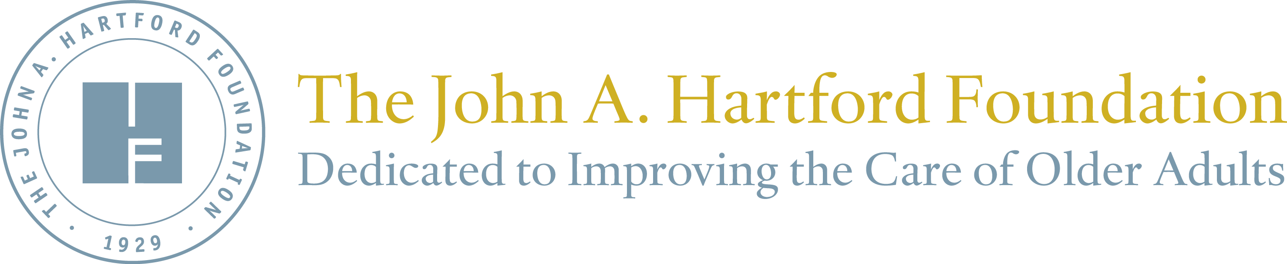
For immediate release

HEALTH AFFAIRS GRANTWATCH Documents THE JOHN A. HARTFORD FOUNDATION’s IMPACT on THE GROWTH OF GERIATRICS over 30 years

New York, NY (January 7, 2019) – Health Affairs has published a new GrantWatch article today in its January issue, “The John A. Hartford Foundation and The Growth of Geriatrics,” by Stephen Isaacs, JD, and Paul S. Jellinek, PhD, both founders and partners at Isaacs/Jellinek, and Terry Fulmer, PhD, RN, FAAN, President of The John A. Hartford Foundation. The paper evaluates the impact of The John A. Hartford Foundation’s past thirty-plus years of grant making in aging and health, totaling an investment of nearly a half-billion dollars.
The evaluation, conducted by Isaacs/Jellinek, a consulting company that works with foundations, found that The John A. Hartford Foundation has improved the care of older adults in the United States by:
- Playing an instrumental role in creating the field of geriatrics, a new field in American health care, “essentially from scratch”
- Working to ensure that “all of the nation’s practicing physicians, nurses, and social workers who provided care to older adults received at least some geriatrics training during their professional education”
- Supporting palliative care – which has now been widely adopted by the U.S. health care system – for many years
- Helping to reduce the stigma of caring for older people

“This assessment confirms what we’ve long believed - that The John A. Hartford Foundation is making a meaningful difference in the care of older adults through strategic, long-term collaboration with a diverse array of partners, evidence-based learnings, and a proven track record of results,” said The John A. Hartford Foundation President Terry Fulmer.
The evaluation was conducted through a quantitative assessment of the output and impact of the Foundation; a qualitative assessment of its cumulative impact; and a combined quantitative-qualitative assessment, through trends data and interviews with experts, of the extent to which health care for older adults has improved and how much the Foundation has contributed to this.
Over the past thirty years, The John A. Hartford Foundation has helped increase the number of geriatric physicians, nurses, and social workers, has tested models of care, and continues work to improve the care of older adults. The article details the Foundation’s support for geriatrics training programs and the development of geriatrics as a field, and outlines care models that have been funded (including community-based care team care, transitional care programs for hospitalized older adults, home-based primary and acute care, depression treatment, palliative care, and medication management). Impacts are noted including the incorporation of aging in curricula, accreditation and board certification requirements. For instance, 90% of bachelor’s-level nursing school programs now integrate geriatrics into at least one required course, up from one in five in the late 1970s. In addition, the paper emphasizes changes to geriatrics policy and leadership, through supporting influential reports by the Institute of Medicine. Collaborations with other funders, partners and aging-focused organizations and their vital roles in all this work are highlighted.
The paper underscores that the Foundation chose to focus on geriatrics at a time when few others were paying attention, and stresses the long-term, steadfast commitment of the Foundation to addressing “one of the most urgent challenges facing modern society: the aging of the population. Many of the leaders interviewed for this evaluation commented on—and marveled at—the Foundation’s sustained focus.” The Foundation has developed and implemented a carefully reasoned strategy of mutually reinforcing programs and activities; monitored and learned from its experiences and modified its approach as needed; and actively sought funding partners. Geriatrics, the article says, is “now a recognized medical, nursing, and social work specialty.”
The John A. Hartford Foundation was established in 1929 by John and George Hartford, the founders of the Great Atlantic & Pacific Tea Company (also known as the A&P grocery stores). In 1983, the Foundation elevated geriatrics as one of its two priority areas, and in 1994, the Foundation identified improving the care of older adults as its sole priority, focusing on geriatrics at a time when there was little funding for this area.
Health Affairs GrantWatch article link: “The John A. Hartford Foundation and The Growth of Geriatrics”
Isaacs/Jellinek evaluation report link: “Assessment of the Accomplishments and Impact of The John A. Hartford Foundation’s Grantmaking in Aging and Health, 1983-2015”
*********

About The John A. Hartford Foundation
The John A. Hartford Foundation, based in New York City, is a private, nonpartisan, national philanthropy dedicated to improving the care of older adults. The leader in the field of aging and health, the Foundation has three priority areas: creating age-friendly health systems, supporting family caregivers, and improving serious illness and end-of-life care. For more information, visit johnahartford.org and follow @johnahartford.

Media contact:
Marcus Escobedo, Sr. Program Officer & Communications Director
212-832-7788; marcus.escobedo@johnahartford.org

